1. Explain SDLC with diagram.

(SDLC) is a process used by the software industry to design, develop and test high quality softwares. It  is a framework defining tasks performed at each step in the software development process.

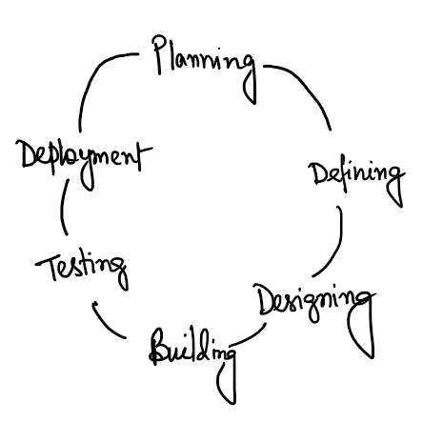

1. How is Design phase different from Implementation phase? Give examples of the outcomes of Design phase.

In the design phase the requirement gathered in the SRS Document is used as an i/p whereas in the implementation phase the software design is translated into the source code.

Outcome of the design phase :

It helps in specifying hardware and system requirements and also helps in defining overall system architecture.